**Visual Programming**

* **Muhammad Hassan Nizaal -213060**
* **Ali Shaan - 213033**

Online Bus Booking System

**Introducing the Online Booking System:**

In today's fast-paced world, time is a precious commodity. Whether you're managing appointments for a bustling business or scheduling personal activities, efficiency and convenience are key. That's where the Online Booking System comes in, revolutionizing the way you book and manage resources.

Say goodbye to phone tag and calendar juggling. This web-powered application, built with the cutting-edge ASP.NET Core framework, puts the power in your hands. With an intuitive and user-friendly interface, you can:

* Browse and book available appointments, classes, or resources seamlessly 24/7. No more waiting on hold or chasing down emails – find what you need, when you need it.
* Manage your bookings with ease. View past and upcoming appointments, reschedule or cancel with a few clicks, and update your information as needed.
* Gain valuable insights through data and analytics. Track booking trends, analyze user behavior, and optimize your resource allocation for better decision-making.

**Built for Businesses and Individuals Alike:**

* Businesses: Streamline your operation and enhance customer satisfaction with a self-service booking portal. Reduce manual workload, eliminate scheduling errors, and gain valuable data on bookings and resource utilization.
* Individuals: Take control of your personal schedule and simplify your life. Book appointments for fitness classes, doctor visits, or any other service quickly and efficiently. Access your bookings on the go from any device and stay organized.

**Powered by Technology, Driven by Efficiency:**

This application harnesses the power of ASP.NET Core, a modern and robust framework, to deliver a secure and reliable booking experience. A dedicated SQL database ensures data integrity and scalability, allowing you to handle even the most demanding booking needs.

Ready to experience the future of booking? Dive into the rich features of the Online Booking System and discover a world of convenience and control.

This introduction provides a starting point for your project. You can tailor it further by:

* Adding specific details about your application's unique features and functionalities.
* Highlighting the target audience and its specific needs.
* Emphasizing the benefits of using your application over other booking solutions.

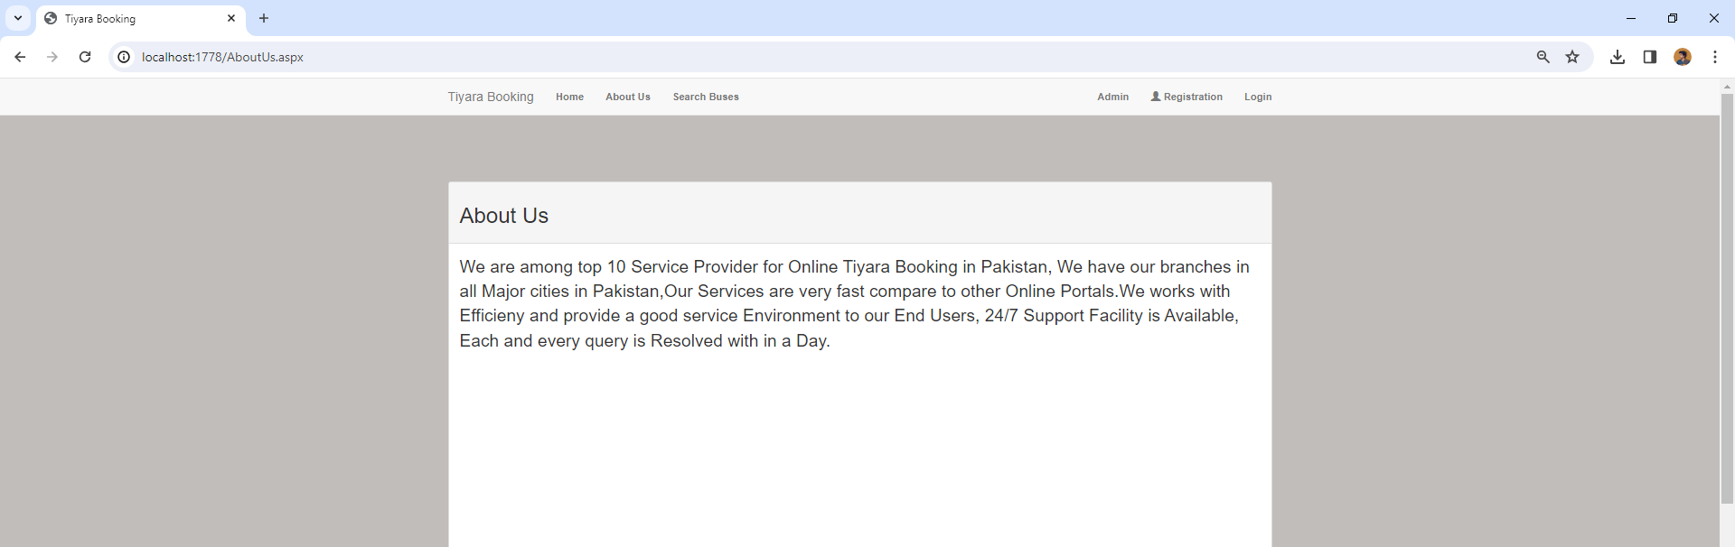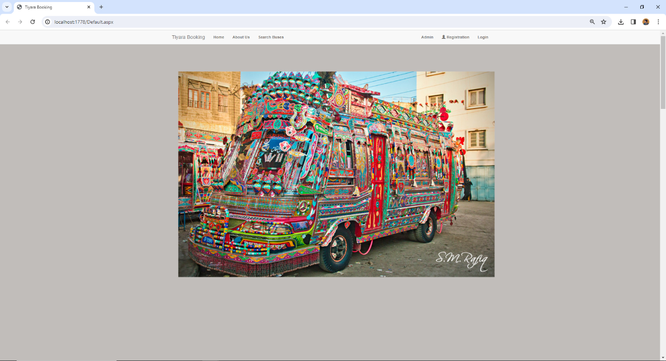

## Detailed Features and Functionalities for the Online Booking System

**User Features:**

* **Booking:**
  + Search for available appointments by date, time, service, or resource type.
  + View detailed information about each appointment, including description, duration, and provider.
  + Select desired date and time, and choose from available options (e.g., individual, group sessions).
  + Enter necessary details for booking confirmation, such as name, contact information, and any special requests.
  + Receive instant confirmation with booking details via email and/or SMS.
  + Manage bookings: view upcoming appointments, reschedule or cancel bookings, access booking history.
* **Account Management:**
  + Create and manage user accounts with secure login credentials.
  + Update personal information, preferences, and communication settings.
  + Store frequently used contact information and payment methods for faster booking checkout.
  + Access booking history and download receipts.
* **Additional Features:**
  + Search by location for geographically dispersed services or resources.
  + Leave reviews and ratings for service providers or experiences.
  + Subscribe to notifications for booking availability updates or special offers.
  + Integrate with personal calendars for synced scheduling.

**Admin Features:**

* **Resource Management:**
  + Define and manage service offerings, resources, and availability schedules.
  + Set appointment durations, capacities, and price points.
  + Block out unavailable times or create recurring appointments.
  + Add, edit, and delete information about service providers or instructors.
* **User Management:**
  + Manage user accounts, approve registration requests, and assign user roles and permissions.
  + View user booking history and activity logs.
  + Communicate with users directly through the platform.

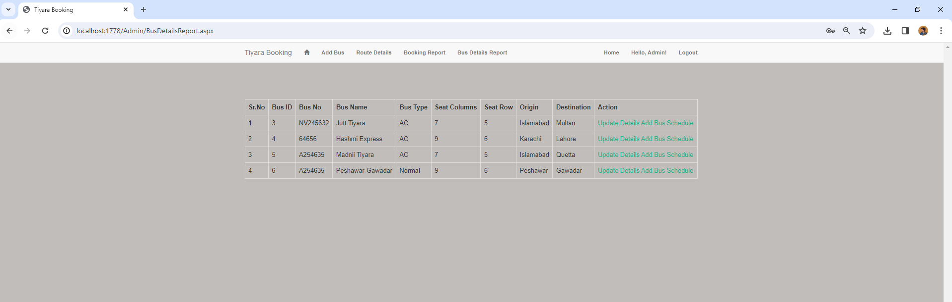

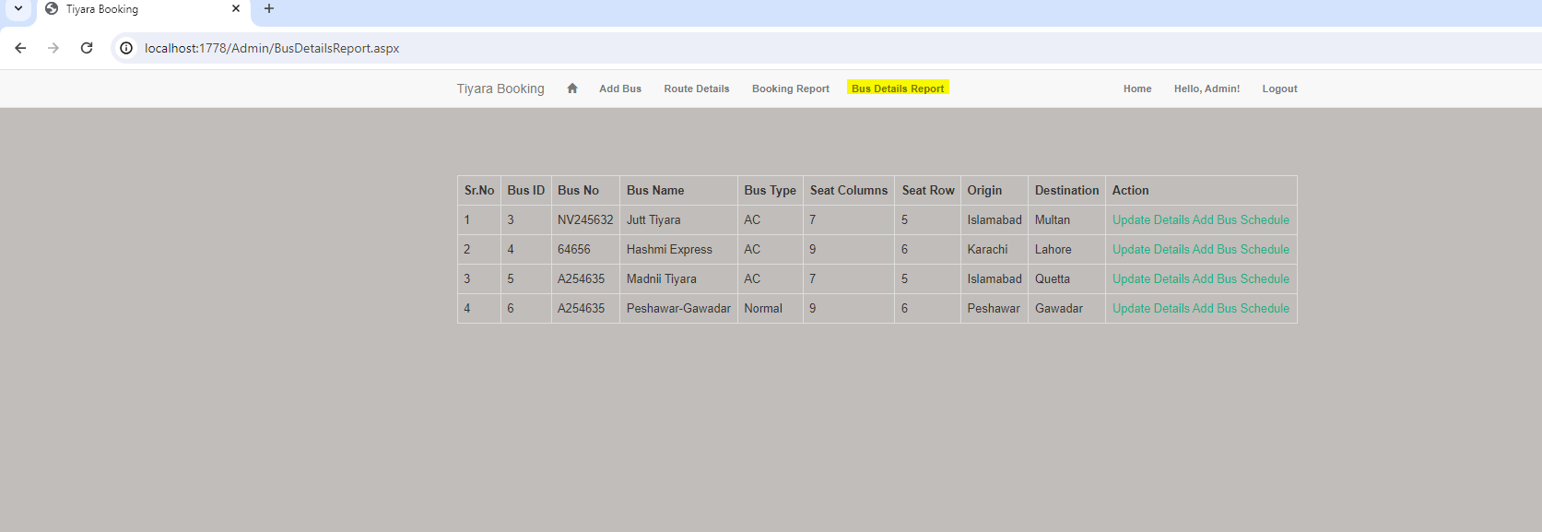

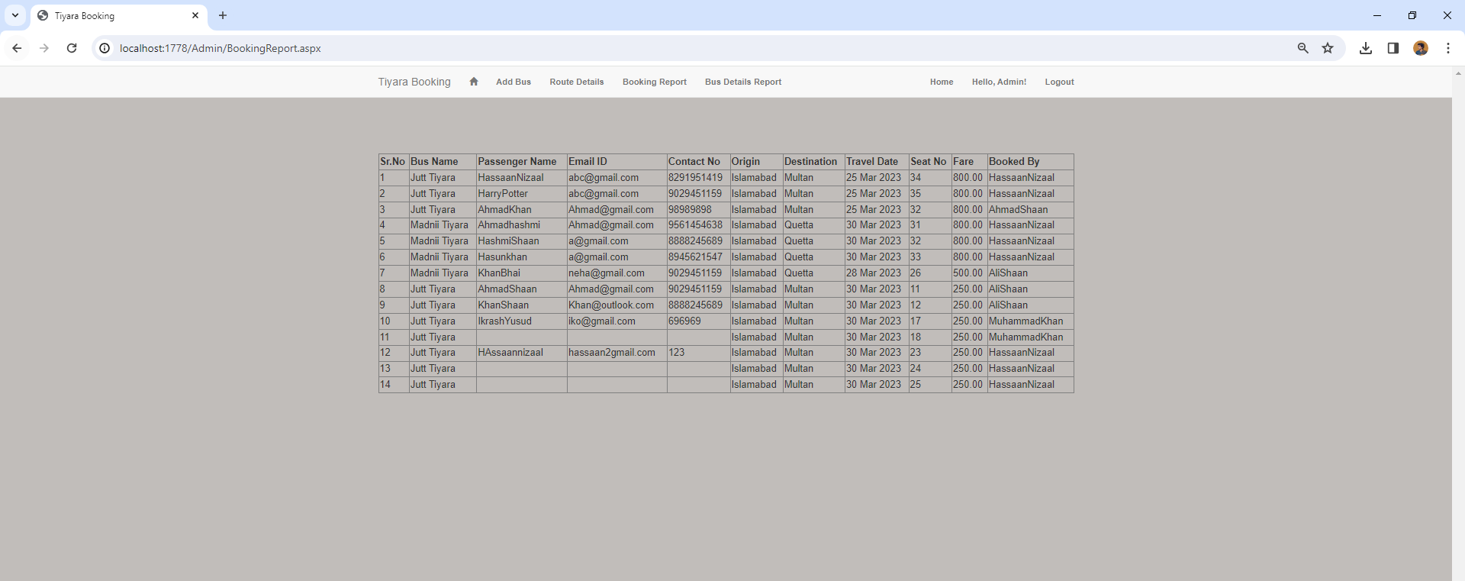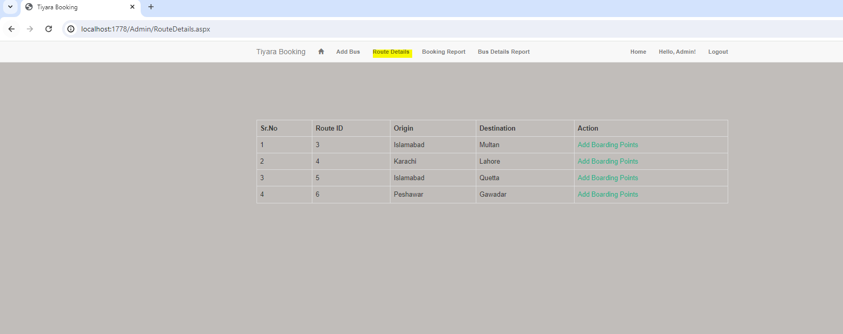

* **Data and Analytics:**
  + Generate reports on bookings, user behavior, and resource utilization.
  + Track booking trends and analyze performance metrics.
  + Identify peak booking times and optimize resource allocation.
  + Export data for further analysis in external tools.
* **Integrations:**
  + Connect with existing business management systems for streamlined data flow.
  + Integrate with payment gateways for secure online transactions.
  + Connect with email marketing platforms for targeted communication.

**Additional Notes:**

* This list is a starting point and can be customized based on the specific needs of your project.
* Consider prioritizing features based on user feedback and business objectives.
* Ensure a user-friendly interface and intuitive workflow for both user and admin functionality.
* Implement robust security measures to protect user data and ensure booking integrity.
* Maintain clear and concise communication throughout the booking process.

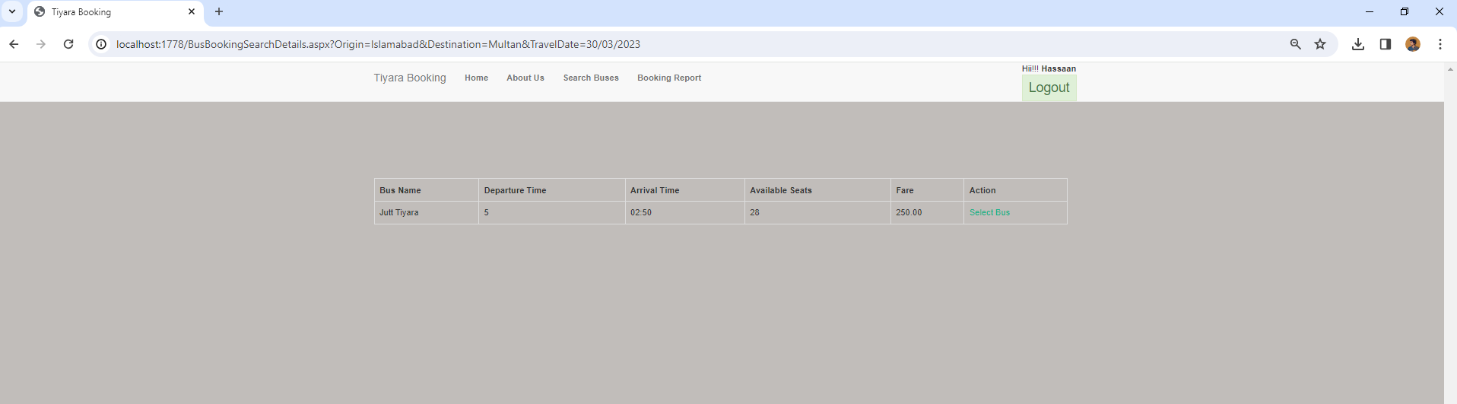By implementing these features and functionalities, your Online Booking System can become a valuable tool for businesses and individuals alike, promoting efficient resource management, enhanced user experience, and valuable data insights for informed decision-making.

**Libraries used for printing tickets for the passengers:**

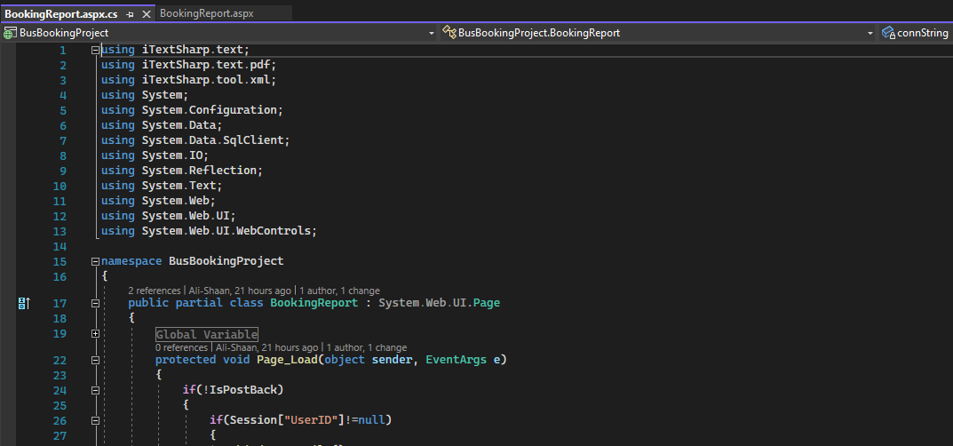

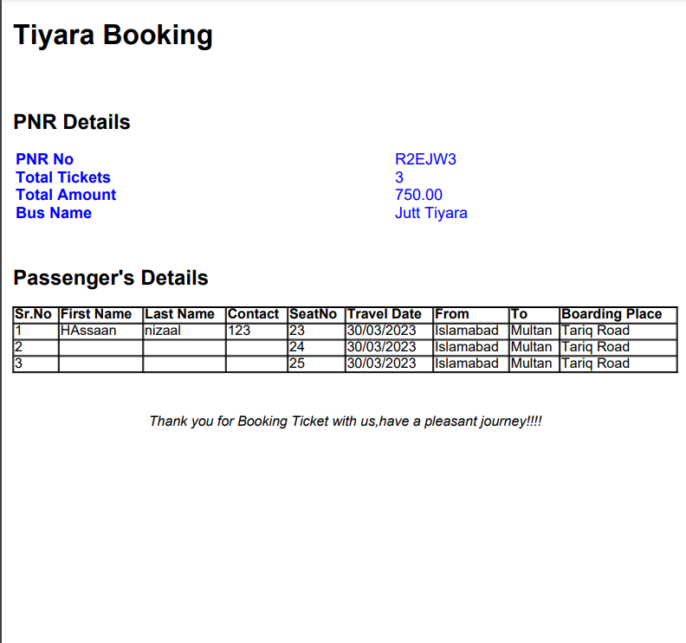

## Unveiling the Advantages: How the Online Booking System Benefits You

The Online Booking System isn't just a techy tool; it's a game-changer, transforming how you manage time and resources. But beyond the bells and whistles, what tangible benefits does it offer? Let's dive into the advantages for both businesses and individuals:

**For Businesses:**

* **Boost Efficiency and Save Time:** Ditch the phone tag and endless email threads. Automate appointment scheduling, freeing up staff for more strategic tasks.
* **Reduce No-Shows and Double Bookings:** Say goodbye to wasted time and revenue. The system ensures accurate scheduling and prevents conflicting appointments.
* **Enhance Customer Satisfaction:** Offer a seamless booking experience, available 24/7. Let customers book at their convenience, improving satisfaction and loyalty.
* **Gain Valuable Insights:** Track booking trends, analyze user behavior, and optimize resource allocation. Make data-driven decisions to improve your business operation.

**For Individuals:**

* **Take Control of Your Schedule:** Book appointments effortlessly, anytime, anywhere. No more waiting on hold or juggling calendars.
* **Simplify Your Life:** Manage all your bookings in one place. View upcoming appointments, reschedule or cancel with ease, and stay organized.
* **Reduce Stress and Save Time:** Eliminate the hassle of finding appointments and waiting in lines. Book quickly and efficiently, freeing up valuable time for other activities.
* **Enjoy Greater Flexibility:** Find appointments that fit your busy schedule. Search by location, date, time, and service type to find the perfect match.

**Beyond the Benefits:**

The Online Booking System isn't just about convenience and efficiency; it's about **empowerment**. It puts you back in control, whether you're a business owner managing resources or an individual juggling a packed schedule. It's about reclaiming your time, reducing stress, and making the most of every moment.

## Diving into the Online Booking System Database

In the heart of our Online Booking System beats a vital organ: the database. Just like a silent conductor orchestrating the system's symphony, it manages information with precision and ensures everything runs smoothly. But what's actually lurking behind the curtain of tables and records? Let's take a peek!

**The Key Players:**

Imagine a stage filled with various actors, each playing a crucial role in our booking masterpiece. Here are the main ones:

* **Users:** This table stores all user information, from names and emails to account preferences and booking history. Think of it as the cast list, keeping track of everyone involved.
* **Appointments:** This table houses all appointment details, including date, time, service type, duration, and provider. It's the script, outlining the show itself.
* **Resources:** This table holds information about the resources being booked, whether it's a physical space like a meeting room or a service like a haircut. This is the props department, setting the scene.
* **Providers:** This table stores information about service providers, such as instructors, stylists, or doctors. They're the talented actors making things happen.

**Details:**

These tables work together like a well-rehearsed play. When a user searches for appointments, the system filters through the "Appointments" table based on their criteria. Once they select an appointment, the system checks the "Users" and "Resources" tables to ensure availability and compatibility. Then, when the booking is confirmed, the information is saved in both the "Appointments" and "Users" tables, becoming part of the user's booking history.

**Behind the Scenes:**

But the database isn't just a static set of tables. It's dynamic and flexible, ready to adapt to our needs. We can:

* **Scale Up:** The database can grow to accommodate increasing bookings and users without breaking a sweat. Think of adding extra seats to the theater!
* **Customize:** We can add new tables or fields to cater to specific features or business needs. It's like tailoring the costumes to perfectly suit each character.
* **Analyze:** The database is a treasure trove of data. We can extract insights on booking trends, user behavior, and resource utilization, helping us make informed decisions and improve the system. This is like having a backstage spy revealing valuable secrets!

**Our Commitment to Security:**

Just like we wouldn't want anyone peeking into the actors' dressing rooms, we prioritize data security. The database is protected with robust measures like encryption and access controls, ensuring your information remains safe and private.

**In Conclusion:**

The Online Booking System database is more than just lines of code; it's the engine that powers efficiency and empowers both businesses and individuals. By understanding its structure and capabilities, we can appreciate the magic behind the curtain and leverage its power to create a truly remarkable booking experience

**Tables:**

* BookingMaster

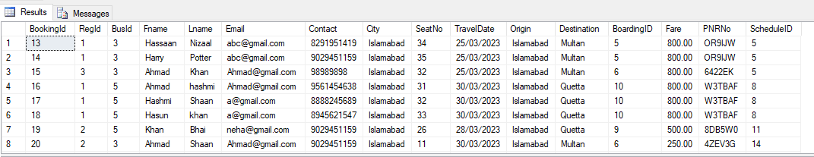

* BusMaster

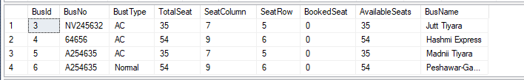

* CardDetails

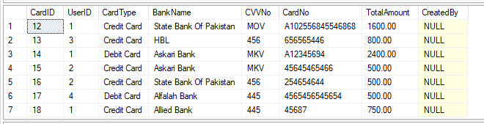

* CityDetails

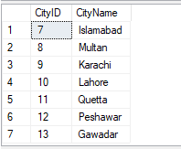

* PickUpStand

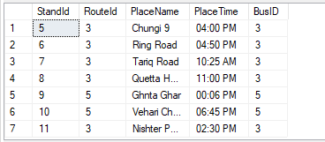

* PNRDetails

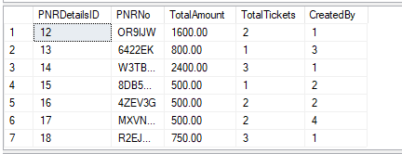

* Registration



* RouteDetails

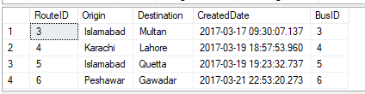

* ScheduleMaster

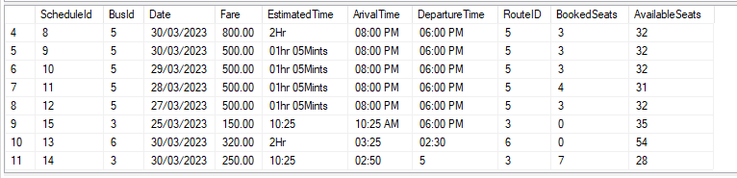

**Conclusion**:

In a world yearning for order, the Online Booking System steps onto the stage, poised to transform booking chaos into a harmonious symphony of efficiency. 24/7 convenience meets data-driven insights, empowering businesses and individuals to reclaim control of their time and resources. So, ditch the calendar juggling and embrace the future – the Online Booking System awaits, ready to conduct your success.